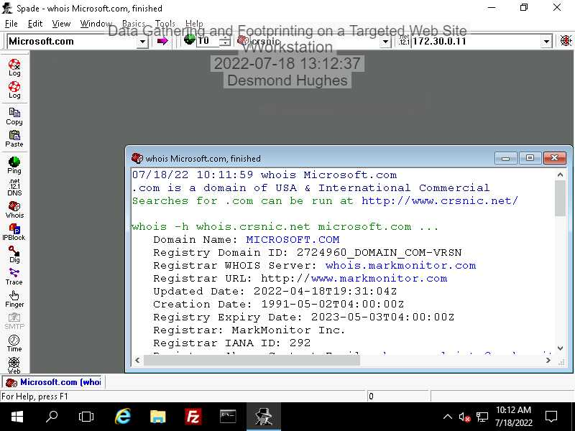

Step 2:

Data Gathering and Footprinting on a Targeted Web Site

Desmond Hughes

Purdue University Global

IT262 Certified Ethical Hacking I

Cheryl Waters

July 18, 2022

Sam Spade runs on all versions of Windows, and used to investigation and analysis. Sam Spade has features to find spam and site spam. Some features run as soon as you download the Sam Spade but some you have to configurate. DNS records are zone files, which provide information about a domain, and what IP address it has.

The method organizations use to know that you are viewing them is Active Footprinting. Active Footprinting. Active Footprinting uses ping and traceroute command to get information about the person viewing them. Footprinting can also be used to carry out attacks, and gain information about the network of the organization.

The result of the Google search “site: amazon -site: www.amazon.com” contained four Amazon websites. One website explaining that they strive to keep the users happy, and a link to their “The Day One” blog. The next website was an Amazon website with WHOIS that helps you search up domain names, registries, nameservers, and IP address. Within their website. The next website contained information on how to place your ads on Amazon. It even helps you by giving you a learning process on what to do and how to reach your target audience using the ad, and get your ads certified. The last website presented Adweek by Amazon Advertising. The website also gives you the name of the speakers of Adweek, and information on how to recalibrate your brand and its purpose.

References

.amazon WHOIS. (2022). Retrieved 20 July 2022, from <http://whois.nic.amazon/>

Adweek At Home 2021. (2022). Retrieved 20 July 2022, from <https://event.adweek.com/adweek-at-home-2021?ref_=amt_bsm_ln_global_en_adweekathome-21_2105&linkId=120002533>

Amazon. (2022). Retrieved 20 July 2022, from <http://nic.amazon/>

Learning console – Amazon Ads training courses and certification. (2022). Retrieved 20 July 2022, from <https://advertising.amazon.com/en-gb/resources/learning-console?ref_=a20m_us_hnav_lc>

Sam Spade. (2022). Retrieved 20 July 2022, from <https://www.garykessler.net/library/is_tools_sam_spade.html#:~:text=Sam%20Spade%20runs%20on%20all,contents%20of%20a%20Web%20page>.

(2022). Retrieved 20 July 2022, from <https://www.cloudflare.com/learning/dns/dns-records/#:~:text=DNS%20records%20(aka%20zone%20files,handle%20requests%20for%20that%20domain>.